# Final Assignment

## Loading data:

1. Created a database for the final assignment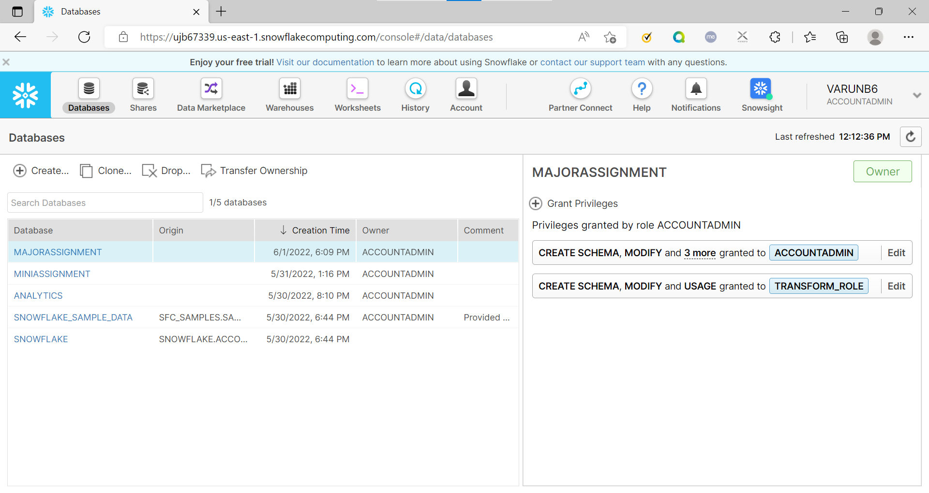
2. Created mutual funds table for loading mutual fund data from csv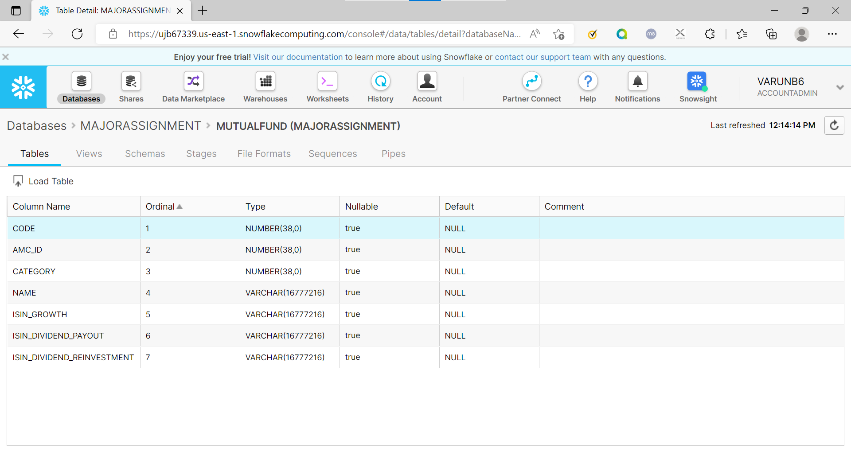
3. Created fundcategory table to load fundcategory data from csv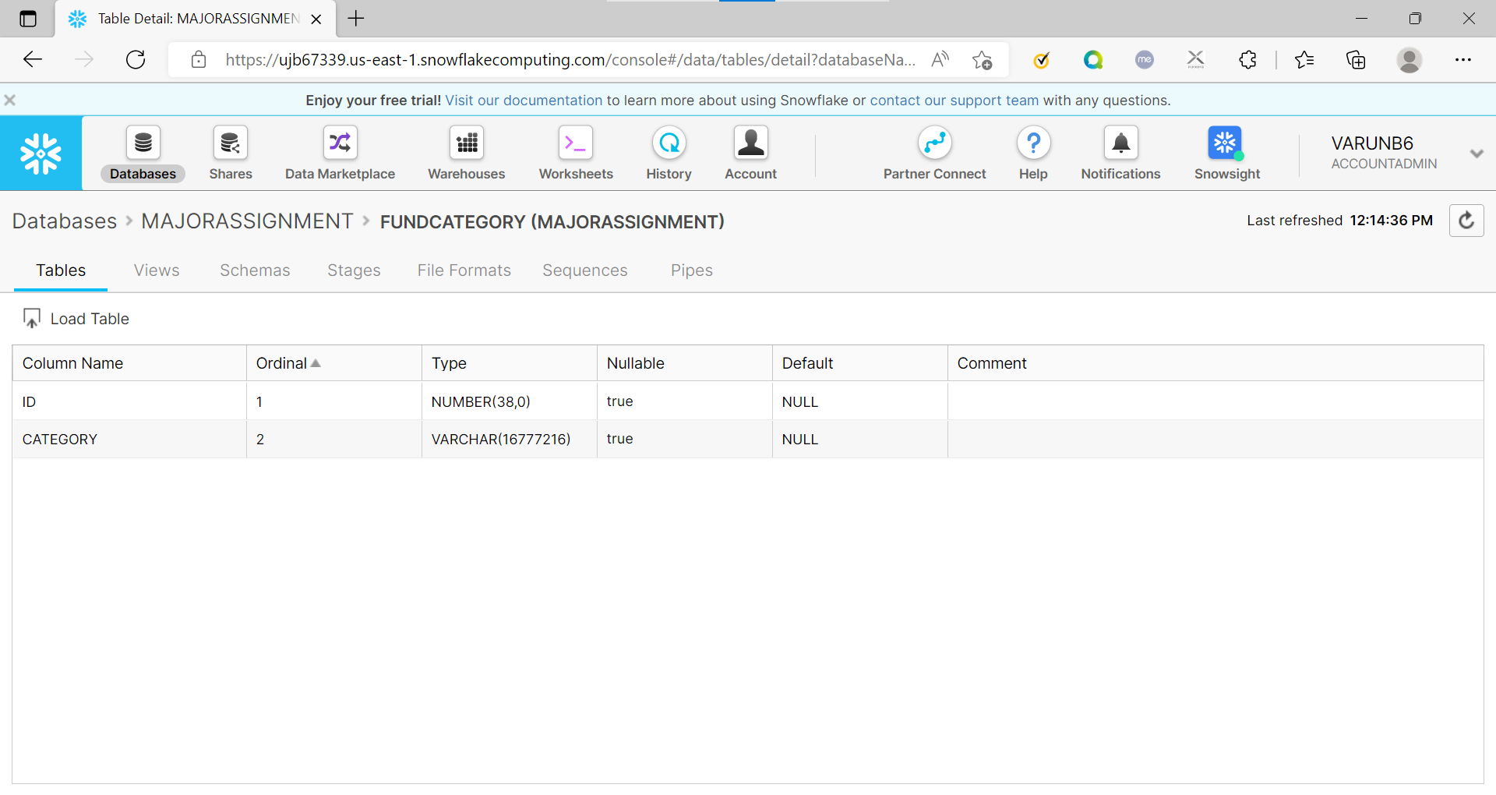
4. Created amc table to load amc data from csv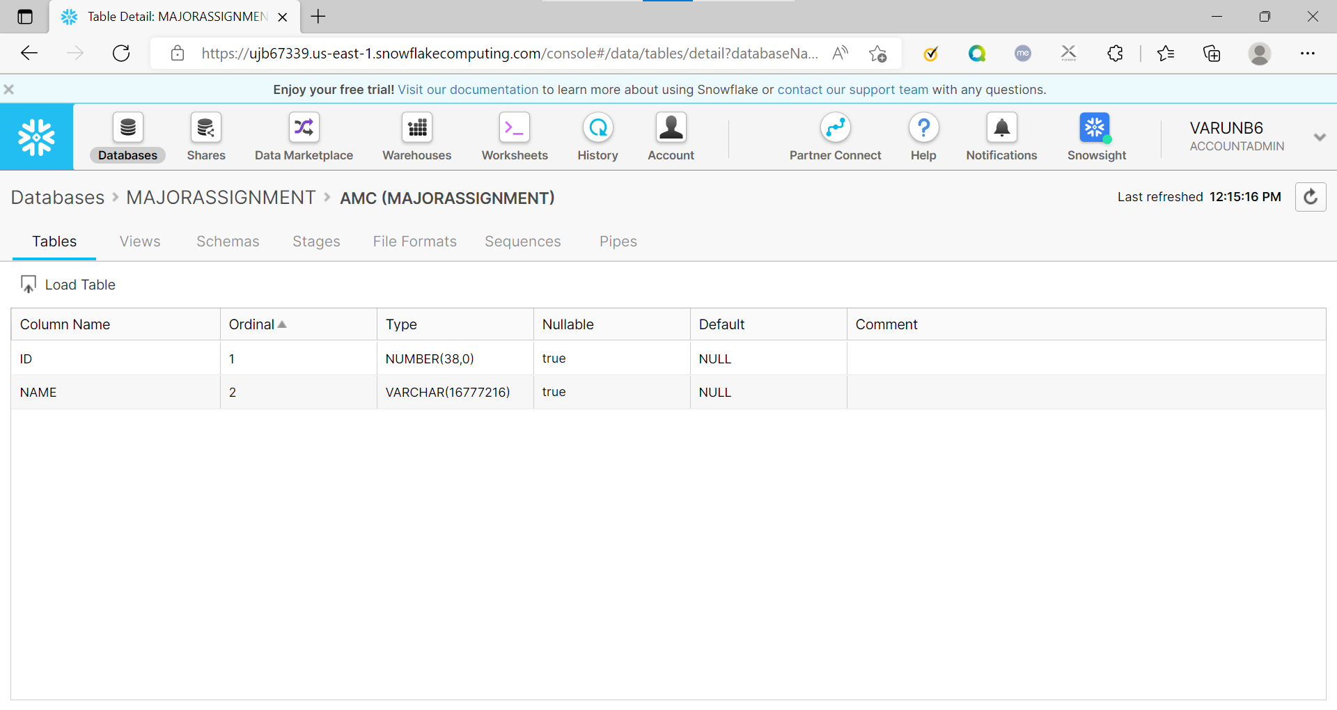
5. Created navhistory table to load navhistory data from csv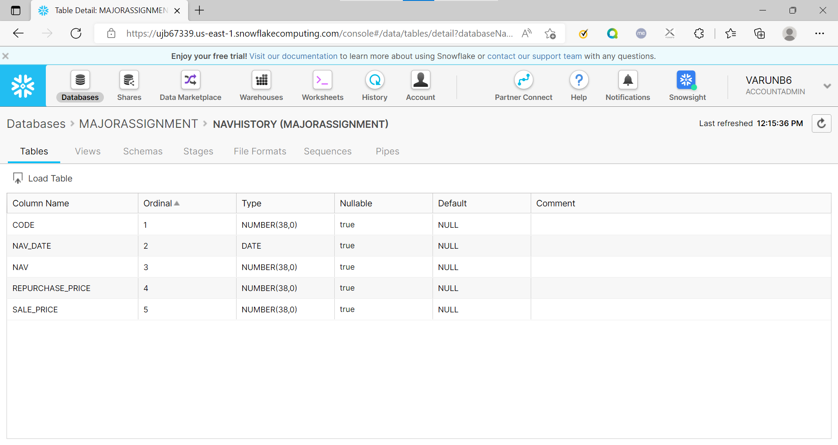
6. Loaded data using web ui through following steps:
   1. Selected warehouse

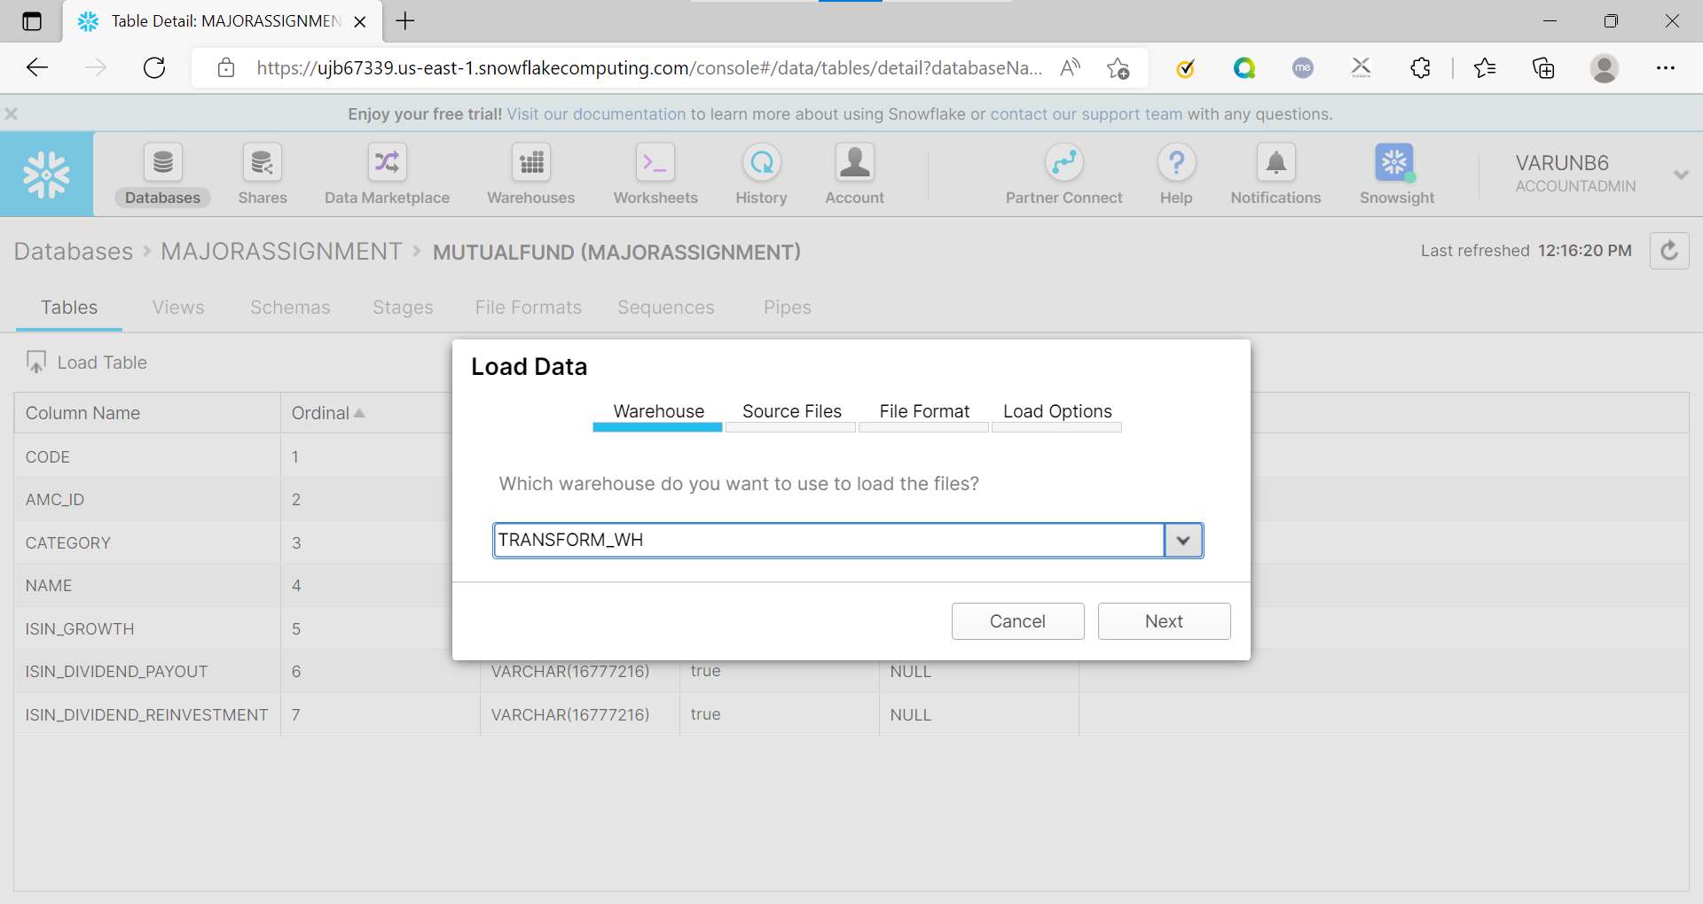

* 1. Selected files for uploading

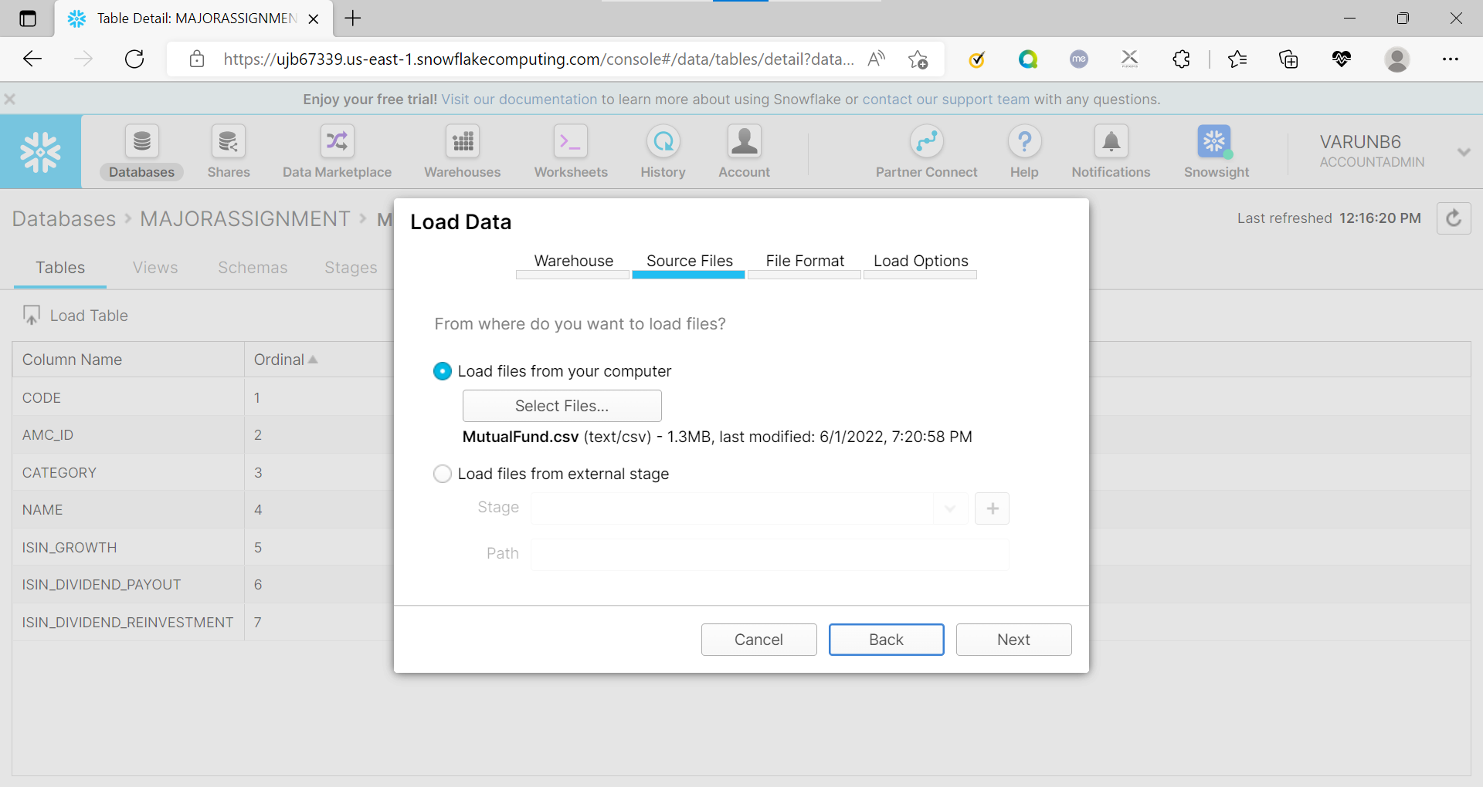

* 1. Selected file format specification and loaded data

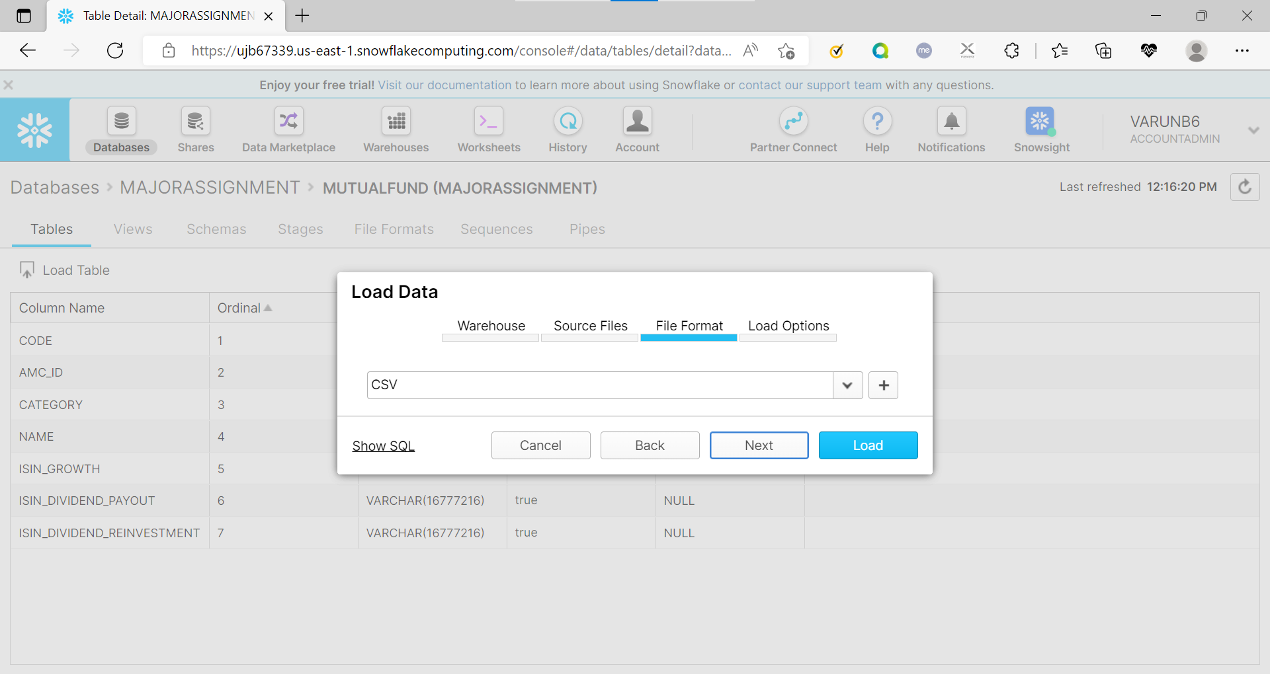

## Milestone 1:

**Q1: Calculate Monthly average NAV, Repurchase & Sale Price for each scheme**

Query:

select f.category,month(nav_date) as mon,avg(nav) as avg_nav,avg(repurchase_price) as avg_repurchase_price,avg(sale_price) as avg_sale_price

FROM

"MAJORASSIGNMENT"."MAJORASSIGNMENT"."NAVHISTORY" n join "MAJORASSIGNMENT"."MAJORASSIGNMENT"."MUTUALFUND" m

on n.code=m.code join "MAJORASSIGNMENT"."MAJORASSIGNMENT"."FUNDCATEGORY" f

on m.category=f.id group by f.category,mon order by f.category,mon;

**Q2: Find out each scheme’s Max and Min NAV value and Date it occurred**

Query:

WITH Cte AS

(

SELECT nav_date,f.category as category,nav,

ROW_NUMBER() OVER(partition by f.category ORDER BY nav ASC) RN1,

ROW_NUMBER() OVER(partition by f.category ORDER BY nav DESC) RN2

FROM

"MAJORASSIGNMENT"."MAJORASSIGNMENT"."NAVHISTORY" n join "MAJORASSIGNMENT"."MAJORASSIGNMENT"."MUTUALFUND" m

on n.code=m.code join "MAJORASSIGNMENT"."MAJORASSIGNMENT"."FUNDCATEGORY" f

on m.category=f.id

)

SELECT category,

MAX(CASE WHEN RN2=1 THEN nav END) maxnav,

MAX(CASE WHEN RN2=1 THEN nav_date END) maxnavdate,

MAX(CASE WHEN RN1=1 THEN nav END) minnav,

MAX(CASE WHEN RN1=1 THEN nav_date END) minnavdate

FROM CTE WHERE RN1=1 OR RN2=1

GROUP BY category order by category;